(Cover Page)
HIRE IQ: AI POWERED APPLICANT TRACKING SYSTEM
TITLE OF THE DISSERTATION
TITLE OF THE DISSERTATION
(Not more than 3 lines. CAPS Times New Roman Font size 20)
Major Project Report
submitted by

Mr. Shrivathsa

(NNM24MC149)

Under the Guidance of

Ashwini KM  Assistant Professor, Gd-1  Department of MCA  NMAM Institute of Technology, Nitte | Mr. Sudheendra  Project Manager  Softionik Solutions

To
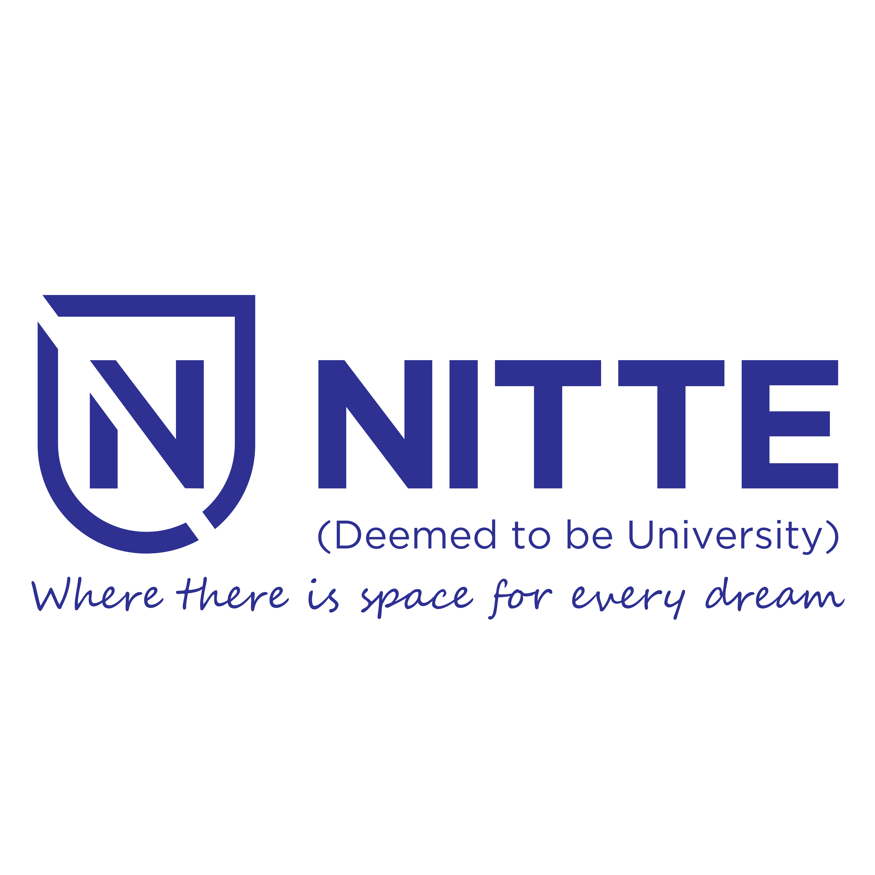
(Estd. under Section 3, UGC Act 1956)
(Placed under Category ‘A’ by MHRD, Govt. of India; Accredited as ‘A+’ Grade University by NAAC)
In partial fulfilment of the requirements for the award of

MASTER OF COMPUTER APPLICATIONS
(Program name in capitals)
DEPARTMENT OF MASTER OF COMPUTER APPLICATIONS
NMAM INSTITUTE OF TECHNOLOGY, NITTE
June 2026
Month Year

